Tutorial-8

Modules name:Amazon
Test Case ID:Amazon
Environment Information:os:macos(Sequoria 15.5)system : laptop(macbook air)webpage URL:https://Amazon.in

Screenshort:
Scenario 1:

Demo login page:Amazon website opened
Test Steps:1a
1.open the amazon website
2.check the browser on open the page

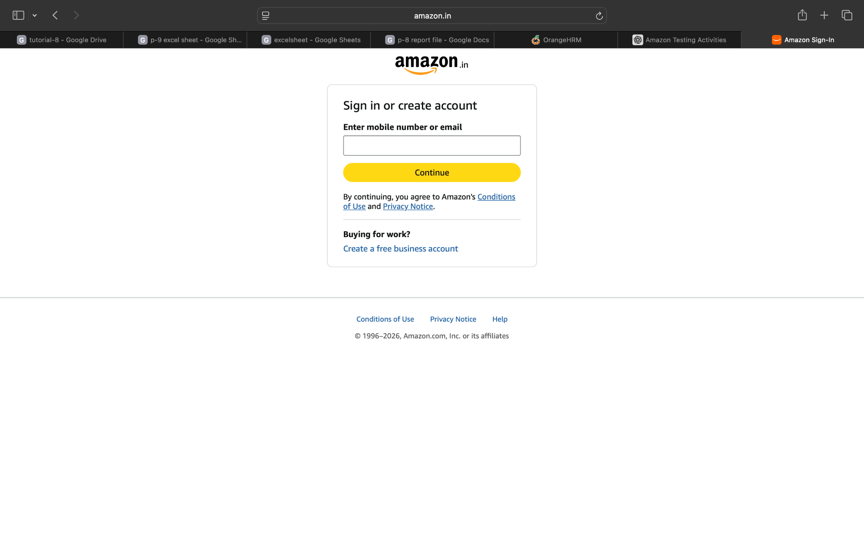
Screenshort:
Scenario 1:

Demo login page:open amazon and login the website
Test Steps:1b
1.open the amazon website
2.click the login page
3.login the page

Screenshort:
Scenario 1:

Demo login page:open amazon and login email & mobile number
Test Steps:1c
1.open the amazon website
2.click the login page
3.page login to email and mobile number

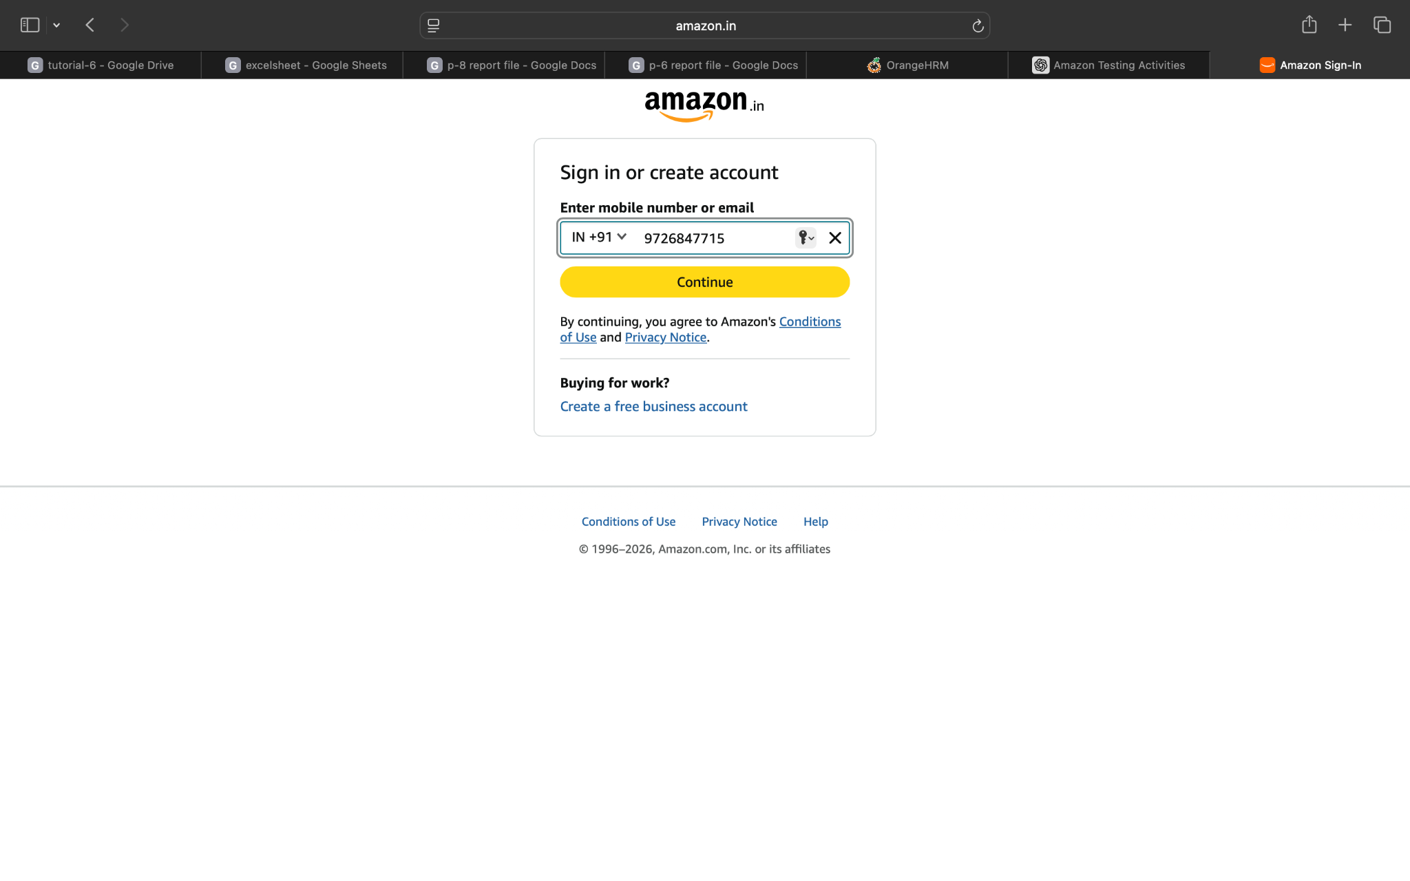

Screenshort:
Scenario 1:

Demo login page:open amazon and invalid email & mobile number
Test Steps:1d
1.open the amazon website
2.click the login page
3.page login to email and mobile number
4.invalid email/mobile number

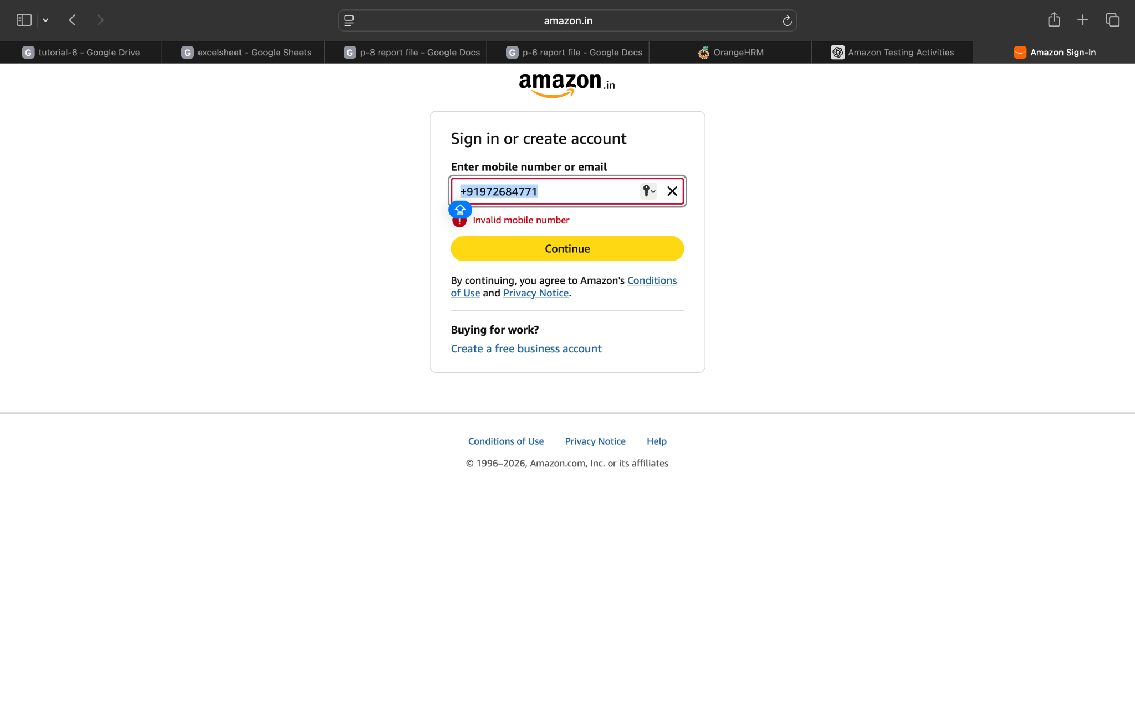

Screenshort:
Scenario 1:

Demo login page:open amazon and enter email & mobile number to valid OTP
Test Steps:1e
1.open the amazon website
2.click the login page
3.page login to email and mobile number
4.enter a valid OTP

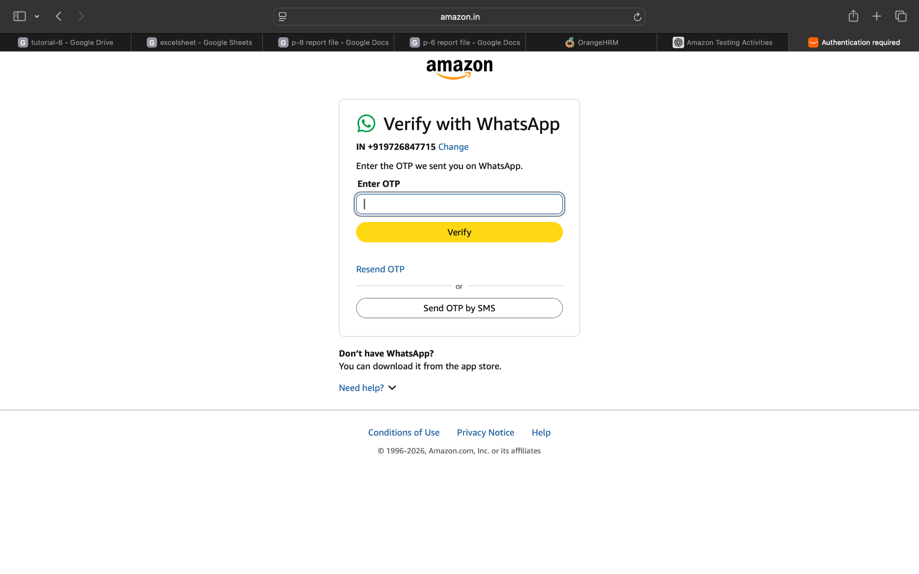
Screenshort:
Scenario 2:

Demo login page:open amazon continue click and open
Test Steps:2a
1.open the amazon website
2.click the login page
3.page login to email and mobile number
4.amazon open the valid OTP and successfully run

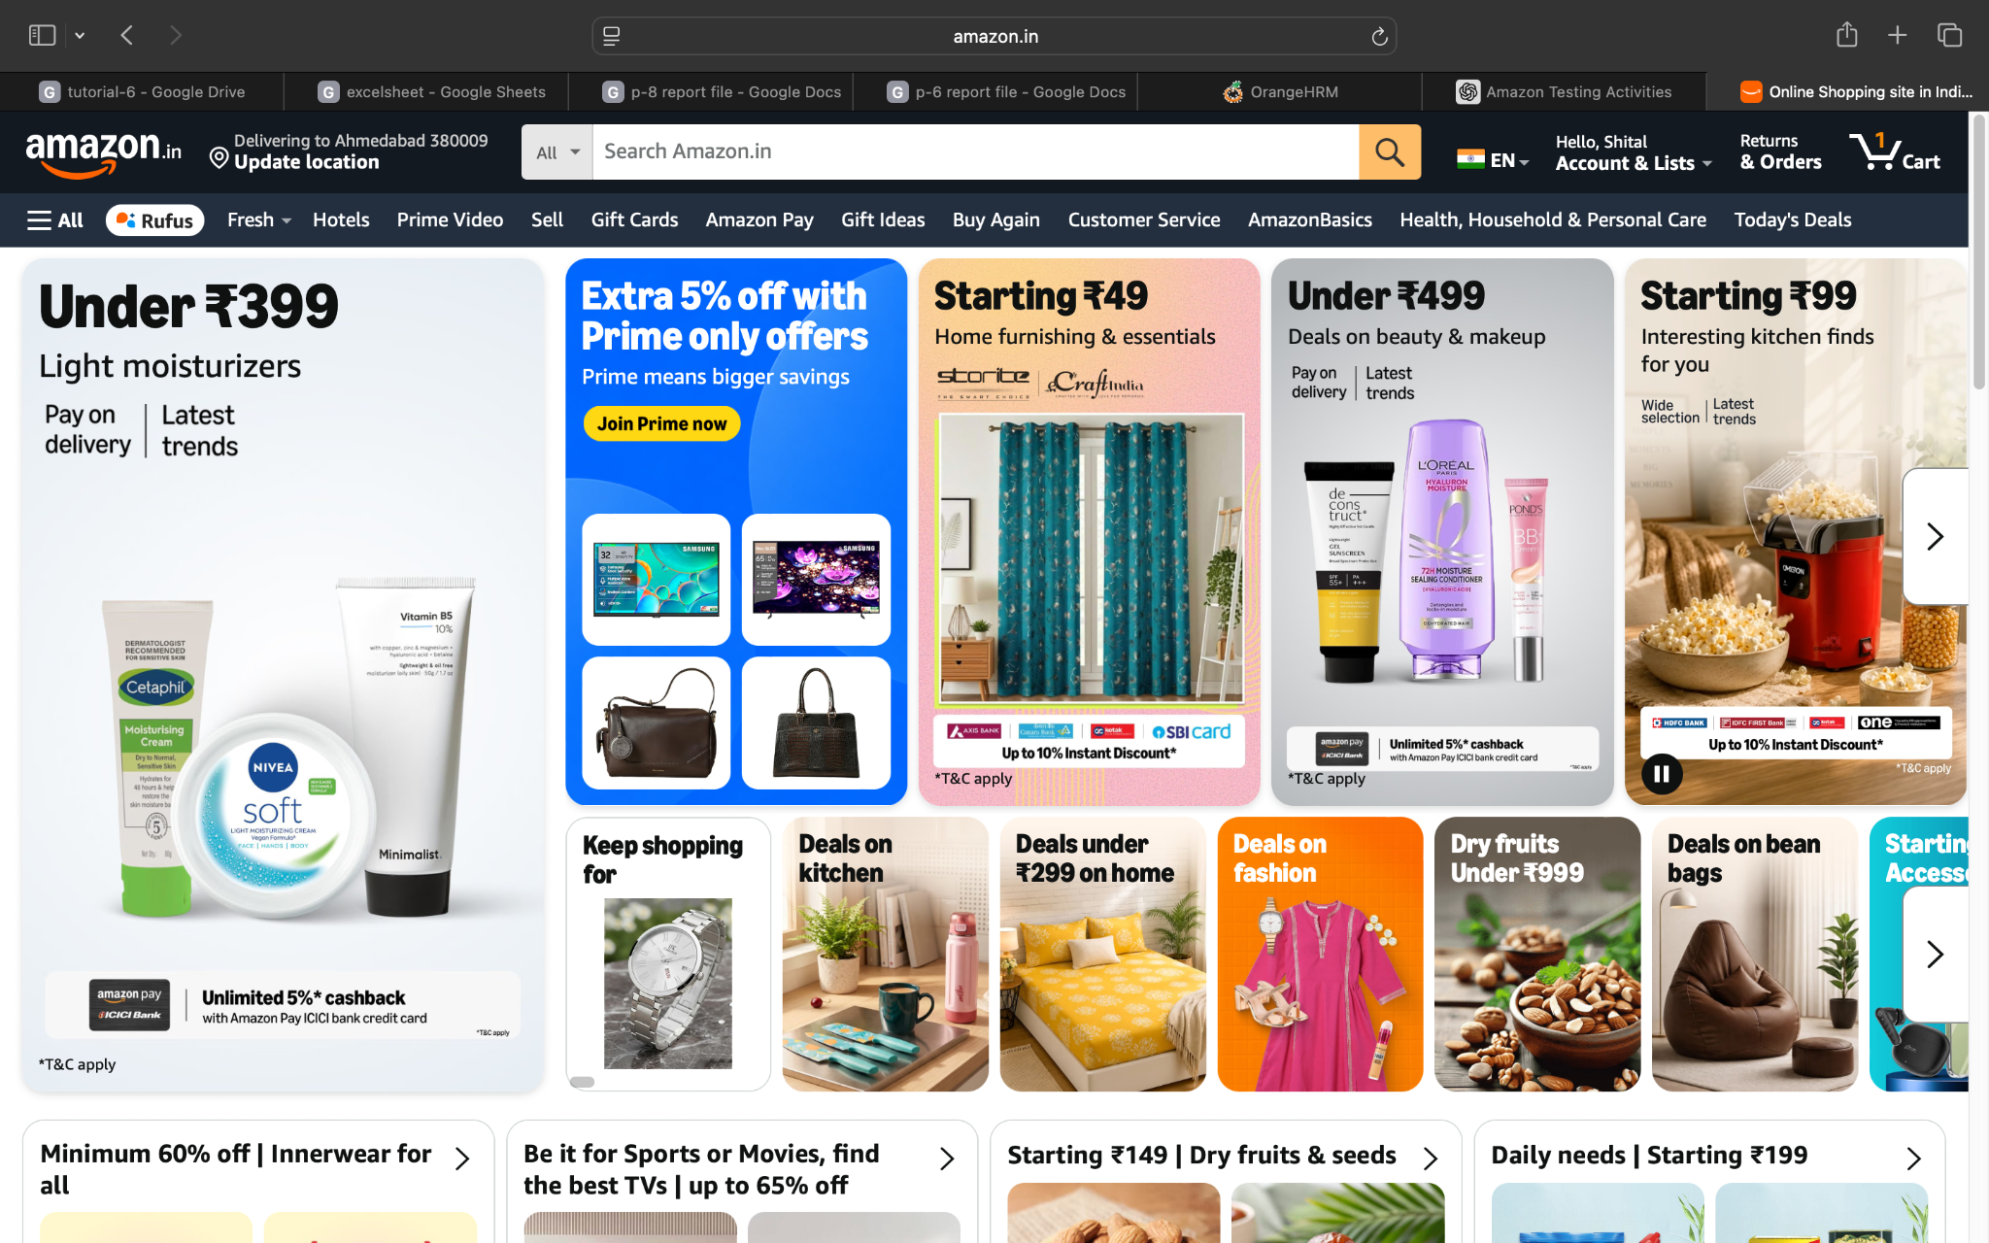

Screenshort:
Scenario 2:

Demo login page:open amazon continue click and open to verify
Test Steps:2b
1.open the amazon website
2.click the login page
3.page login to email and mobile number
4.amazon open the valid OTP and successfully run
5.verify the page

Screenshort:
Scenario 2:

Demo login page:open amazon continue click and check the all menu
Test Steps:2c
1.open the amazon website
2.click the login page
3.page login to email and mobile number
4.amazon open the valid OTP and successfully run
5.verify the page
6.check the all menu

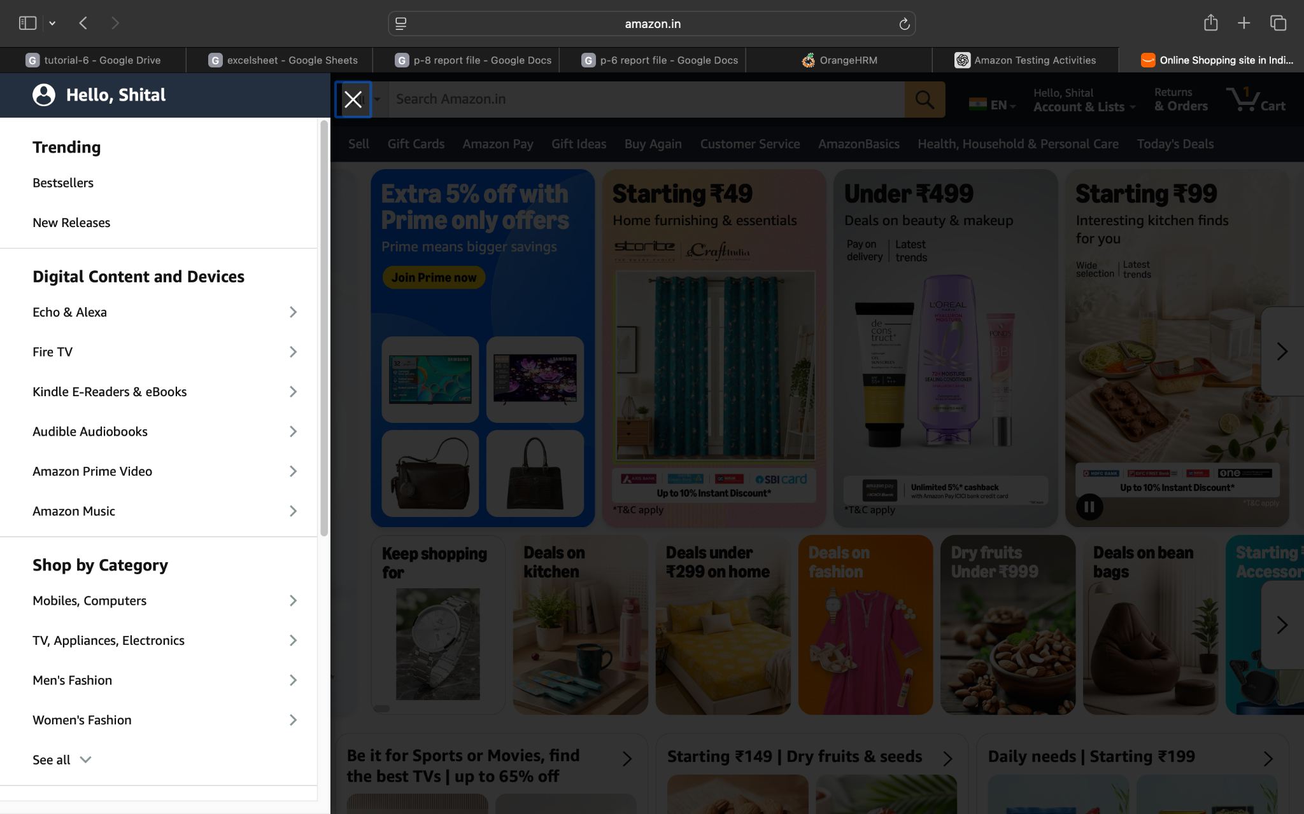

Screenshort:
Scenario 3:

Demo login page:logout the amazon website
Test Steps:3a
1.open the amazon account
2.click the login page
3.page login to email and mobile number
4.amazon open the valid OTP and successfully run
5.verify the page
6.logout the amazon account

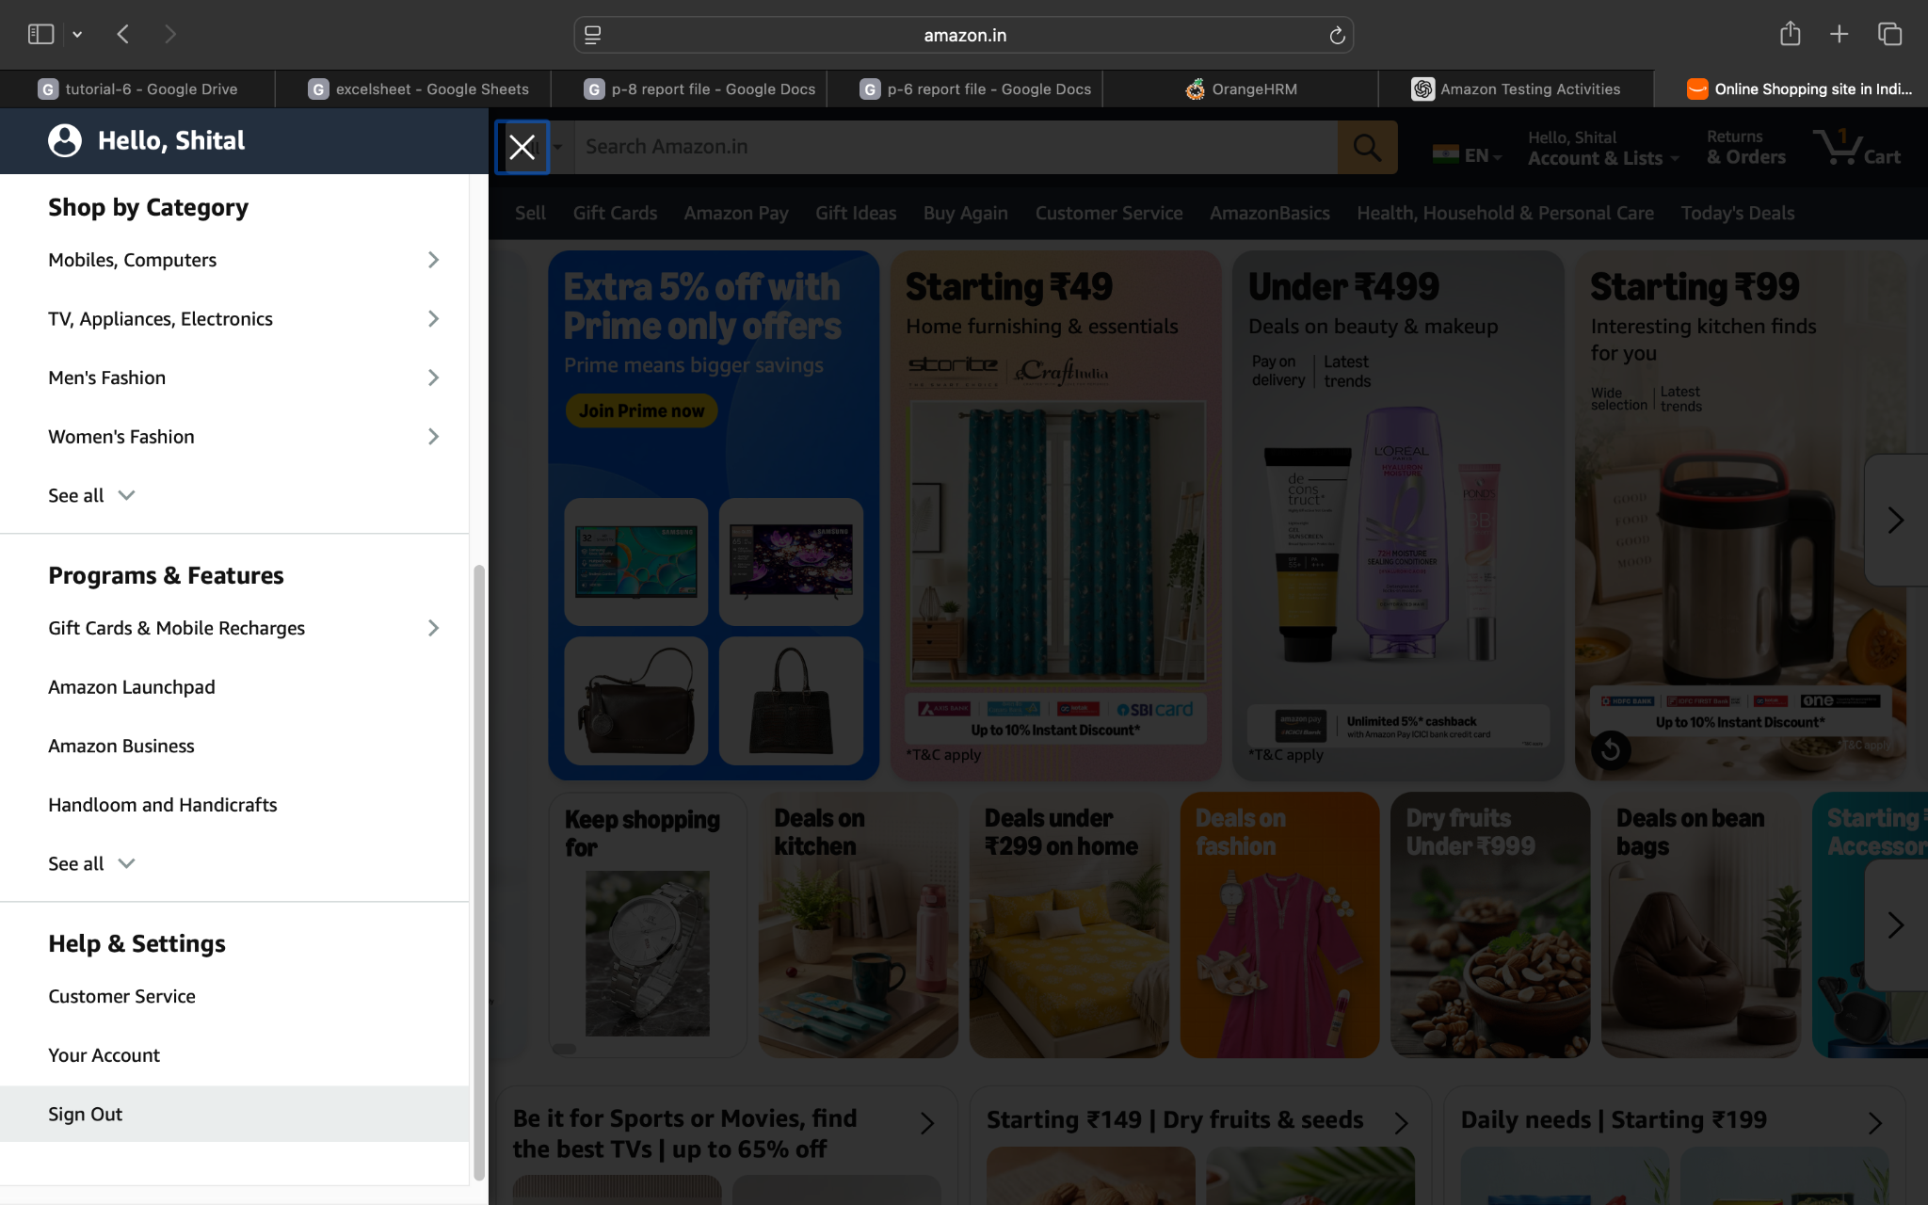

Screenshort:
Scenario 3:

Demo login page:logout the amazon and return the login page
Test Steps:3b
1.open the amazon account
2.click the login page
3.page login to email and mobile number
4.amazon open the valid OTP and successfully run
5.verify the page
6.logout the amazon account
7.login the page is open

